Life for a Child Installation Guide
- Run setup.exe
- Follow the install defaults
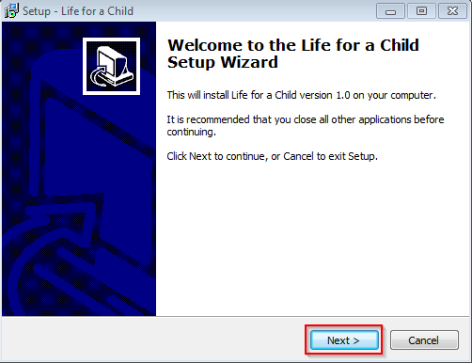
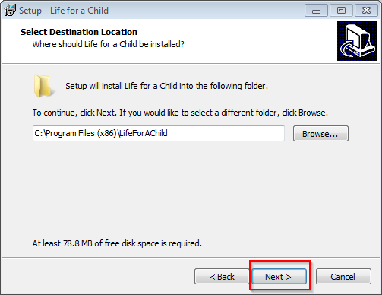
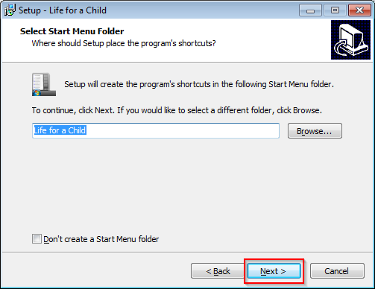
- Tick on “Create a desktop icon” and click Next
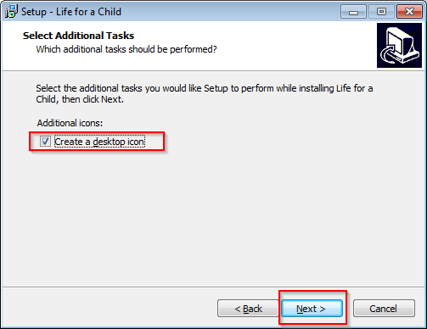
- Click on Install
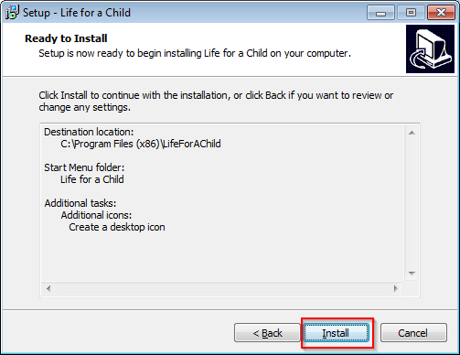
- A window will pop up to install Java. Click on Install.
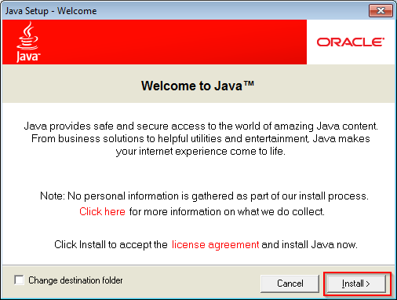
- Once Java finishes installing, click on Close on the confirmation window.
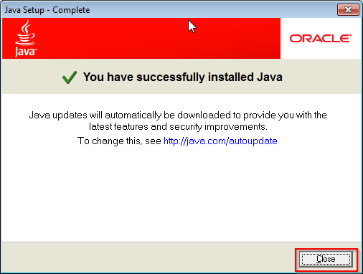
- A window will pop up to install Tomcat. Click on Next.
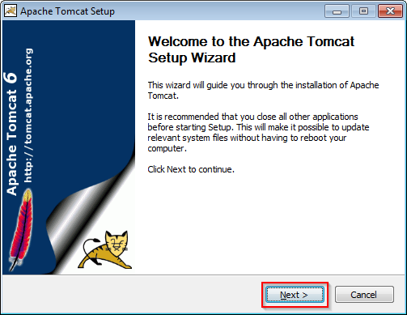
- Click on “I Agree” on the license agreement.
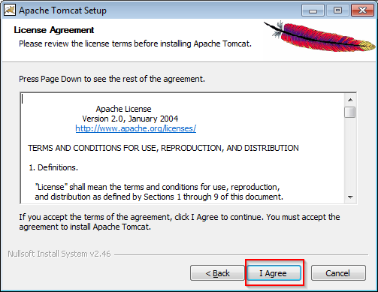
- Click on the plus sign next (+) to Tomcat to expand it
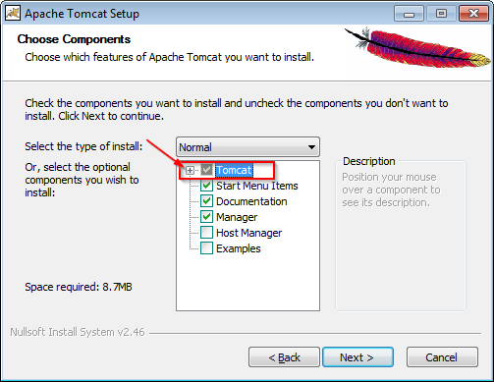
- Tick on “Service Startup”. And click on Next.
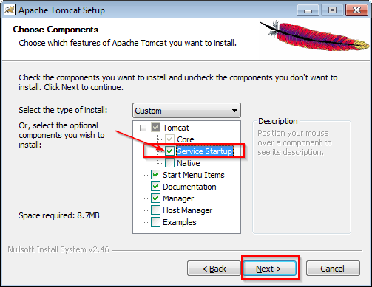

- Configuration Options, leave everything as default and click on Next.
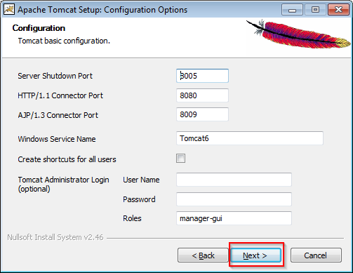

- Configuring path to Java, leave as default and click on Next.
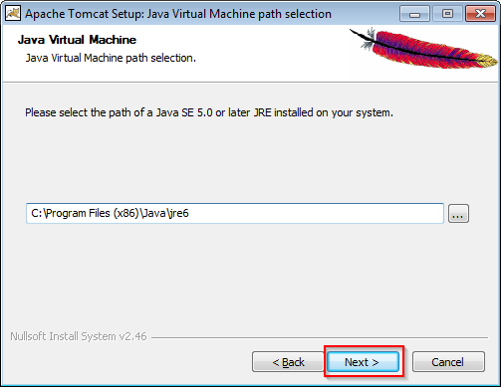

- Leave the default installation path and click on Install.
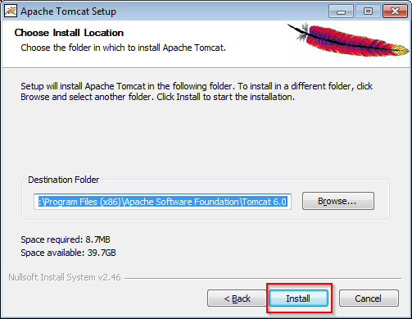

- On the completion installation window, leave everything as default. Click on Finish.
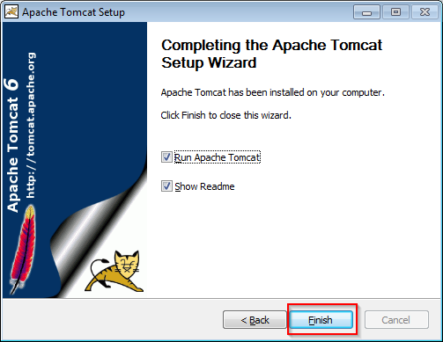

- A window will pop up to install MySQL. Click on Next.
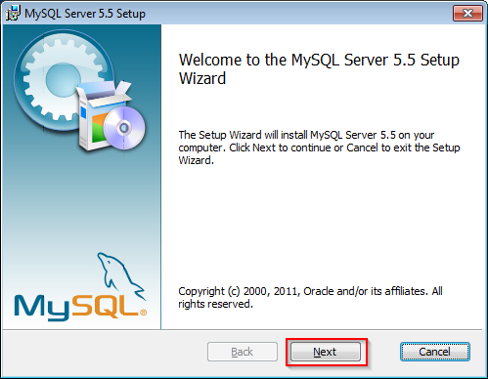

- Tick on “I accept the terms in the License Agreement” and click on Next.
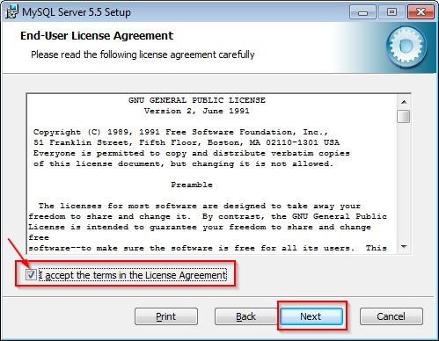

- Click on “Typical” installation.
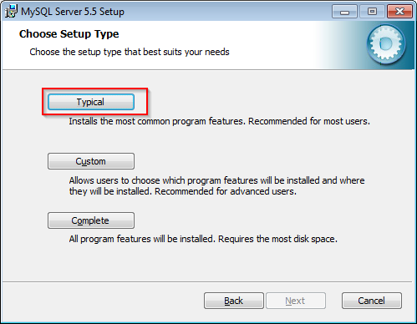

- Click on Install.
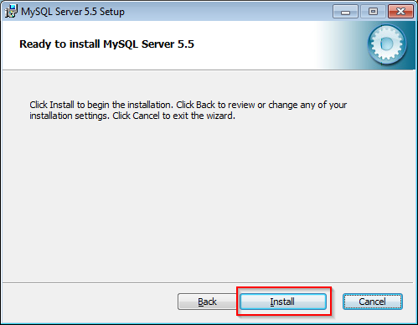
- A window will pop up about MySQL Enterprise. Click on Next, and Next on the next popup.
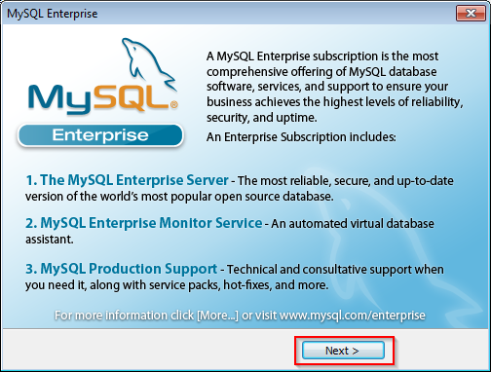
- When installation is complete make sure you UNCHECK 'Launch the MySQL Instance Configuration Wizard'. And click on Finish.
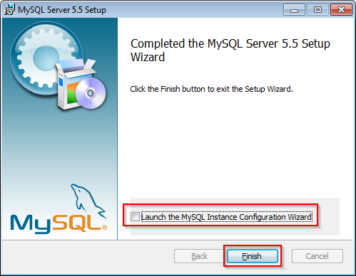

- A DOS window will pop up to perform final installation, it will close automatically.

- Click on Finish on the Completion window.
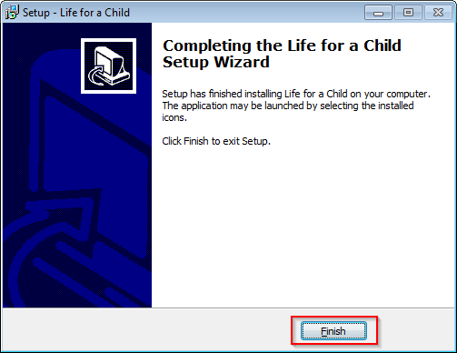

- When setup completes, you can start the application via Start Menu → All Programs → Life for a Child
- Login using the default login:
Name: admin
Password: Passw0rd
- Go to 'List all Users' in the left side menu
- Update the user and change the password to something other than the default.
- Create country and centres as needed.
Uninstall Guide

- Run the uninstaller in Start Menu → All Programs → Life for a Child
- MySQL has to be removed manually. Go to Control Panel → Add or Remove Programs and uninstall, MySQL Server 5.5
- The MySQL database is not deleted on uninstall of the MySQL server, if you wish to delete the data as well delete F:\Documents and Settings\All Users\Application Data\MySQL\MySQL Server 5.5\data

